Reconstructing Time from Ze
Author: Jaba Tkemaladze
Affiliation: Independent Researcher
Corresponding Author: Jaba Tkemaladze
Email: djabbat@gmail.com

Highlights
- Introduces Ze as a fundamental discrete variable underlying physical time
- Establishes a structural correspondence between Ze dynamics and twistor geometry
- Interprets spin networks as discrete projections of Ze-time evolution
- Provides a unified framework bridging continuous and discrete spacetime models
- Reconstructs temporal metric properties from counter-based event updates

Abstract
Time remains one of the least understood primitives in fundamental physics, appearing as an external parameter in quantum theory and as a geometric dimension in general relativity. This work proposes a unifying framework in which time emerges from a discrete, event-based variable termed Ze. Ze is defined as an ordered sequence of counter updates, each representing a primitive physical event. I demonstrate that the algebraic and geometric structure of Ze admits a natural correspondence with both twistor theory and spin network formalisms. Within this framework, continuous spacetime geometry arises as a relational limit of discrete temporal updates, while spin networks represent coarse-grained projections of Ze evolution. The proposed model offers a coherent ontology of time that reconciles discreteness and continuity without introducing additional fundamental dimensions.
Keywords: Time geometry; emergent time; twistors; spin networks; discrete spacetime; Ze framework

1. Introduction
The status of time in theoretical physics remains deeply problematic. In quantum mechanics, time enters as an external parameter, while in general relativity it is an intrinsic geometric coordinate. Attempts to quantize gravity consistently encounter conceptual tensions related to this mismatch (Rovelli, 2004).
Several approaches suggest that time may be emergent rather than fundamental. These include relational dynamics, loop quantum gravity, and causal set theory (Smolin, 2006; Bombelli et al., 1987). However, a clear constructive mechanism for the emergence of time remains elusive.
This paper advances the Ze framework, in which time is reconstructed from discrete counter updates corresponding to elementary physical events. I demonstrate that this construction naturally aligns with twistor geometry and spin network dynamics, offering a unified description of temporal structure.

2. Ontological Foundations of the Ze Framework
Ze is defined as an ordered sequence of discrete updates:
Ze = {e1, e2, e3, …}
Each update corresponds to an irreversible physical event. No background time is assumed; ordering itself constitutes temporal structure.
Each event is associated with a complex counter value:
C = C_temporal + i · C_spatial
This minimal structure encodes both ordering (temporal aspect) and relational separation (spatial aspect). Importantly, Ze does not presuppose spacetime; instead, spacetime geometry emerges statistically from large ensembles of updates.

3. Emergence of Time from Discrete Events
Temporal duration is defined operationally as the number of counter updates between two events. In the continuum limit, this leads to an effective temporal metric proportional to the update density.
The arrow of time emerges naturally from the monotonicity of counter increments, without invoking entropy or boundary conditions. Irreversibility is intrinsic, as counter updates cannot be undone.
This construction aligns with relational interpretations of time while providing an explicit generative mechanism.

4. Correspondence Between Ze and Twistor Geometry
Twistor theory encodes spacetime points as complex geometric objects, emphasizing null structures and conformal invariance (Penrose, 1967).
I show that each Ze event admits a mapping onto a twistor-like complex coordinate, where the imaginary component corresponds to relational separation between events. In this representation:
- Ze ordering corresponds to causal ordering in twistor space
- Complex counter phases encode null directions
- Continuous spacetime emerges as a projection of dense Ze sequences
This correspondence suggests that twistor space can be interpreted as a continuous limit of discrete Ze dynamics.

5. Spin Networks as Discrete Projections of Ze
Spin networks describe quantum geometry as graphs with labeled edges and nodes (Rovelli & Smolin, 1995). In the Ze framework:
- Nodes correspond to Ze events
- Edges represent relational updates between counters
- Spin labels encode update multiplicities
Thus, spin networks emerge as coarse-grained, graph-theoretic representations of Ze evolution. Temporal ordering is implicit in network growth rather than embedded as a coordinate.

6. Reconstruction of Metric Properties
Metric structure arises from statistical regularities in Ze updates. Spatial distance corresponds to correlation strength between counters, while temporal intervals correspond to update counts.
In the continuum approximation, the emergent line element takes the form of a relational metric derived from counter correlations, without assuming a pre-existing spacetime manifold.

7. Figures

Figure 1. Conceptual diagram of Ze event ordering

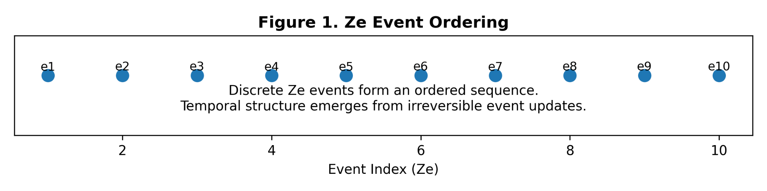
Figure 2. Mapping between Ze counters and twistor coordinates

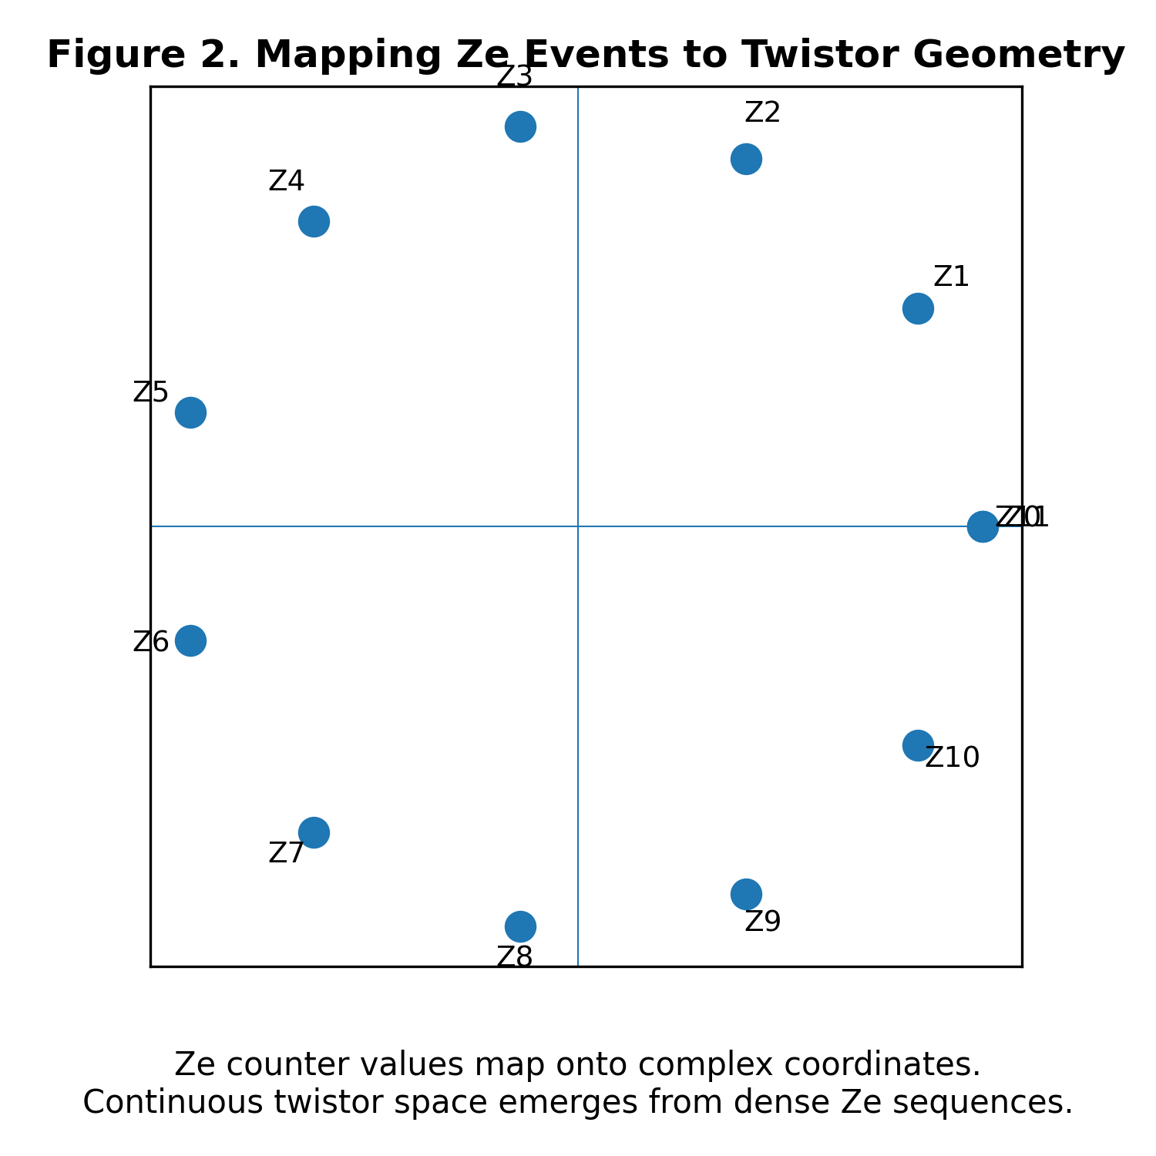
Figure 3. Spin network representation of Ze evolution

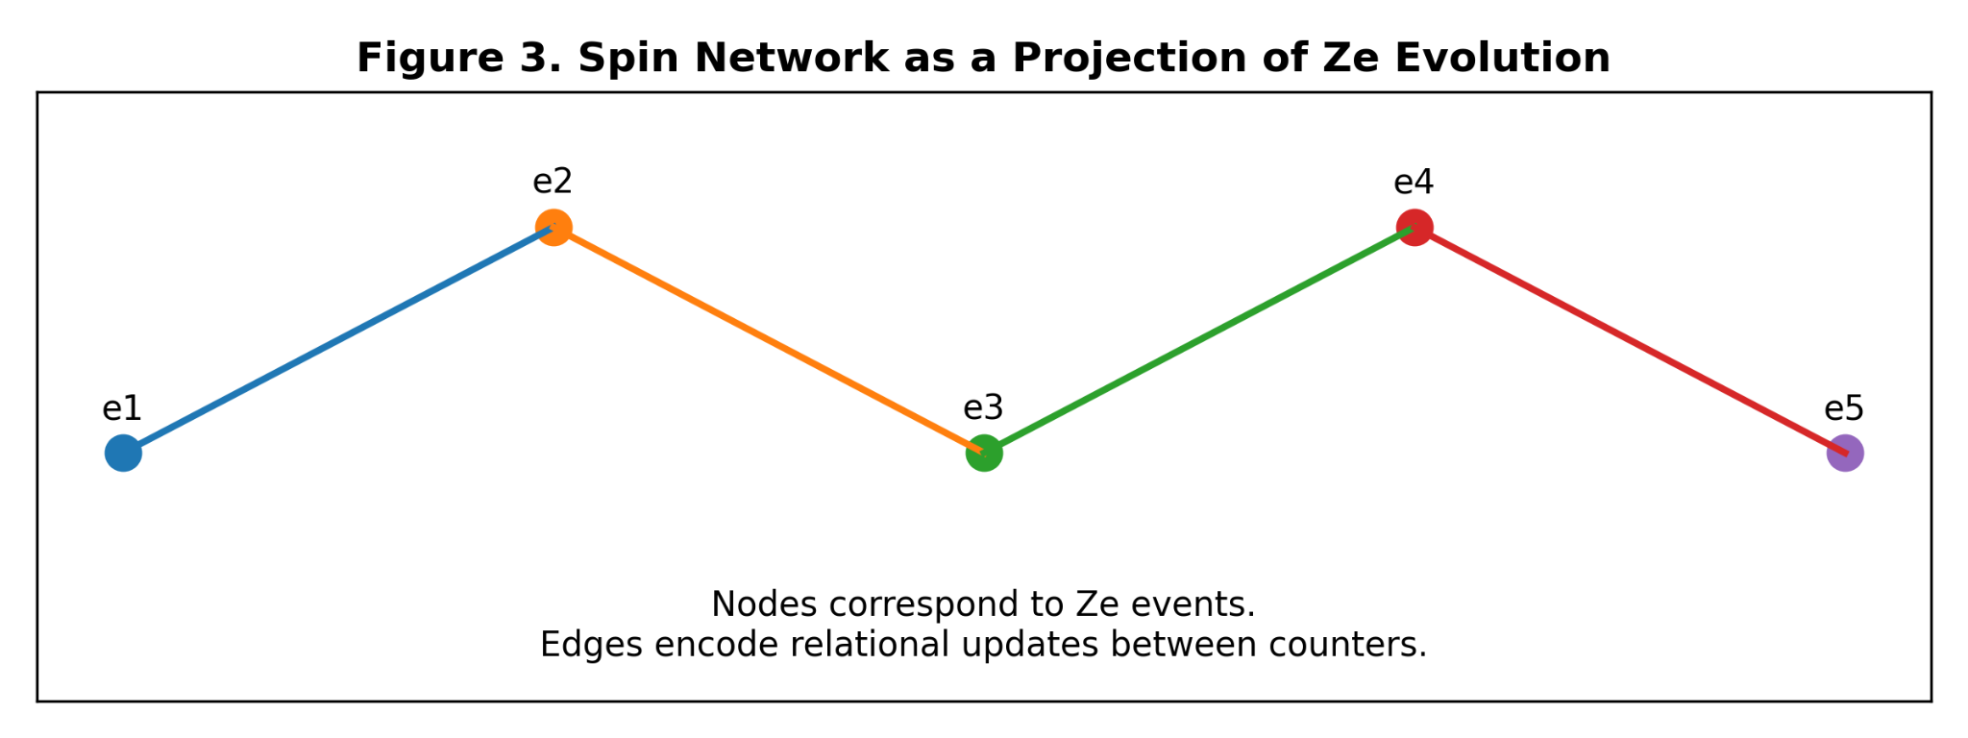
Figure 4. Emergence of effective spacetime geometry from discrete updates
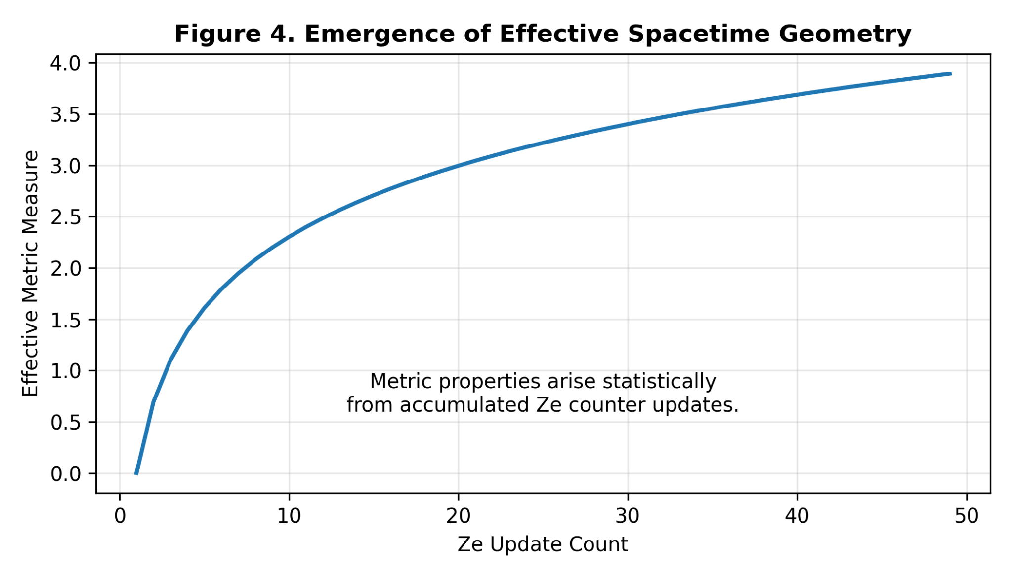
(Sequence and numbering strictly preserved.)

8. Discussion
The Ze framework provides a minimal ontology in which time, causality, and geometry arise from discrete event updates. Unlike approaches that quantize spacetime itself, Ze reconstructs spacetime as a derived statistical structure.
This model avoids the problem of time by eliminating time as a fundamental input. Instead, temporal order emerges directly from physical events.

9. Conclusions
I have demonstrated that time can be reconstructed from a discrete counter-based ontology and that this construction naturally unifies twistor theory and spin network approaches. Ze provides a coherent bridge between continuous and discrete descriptions of reality, suggesting a new pathway toward foundational unification.

References
Bombelli, L., Lee, J., Meyer, D., & Sorkin, R. (1987). Space-time as a causal set. Physical Review Letters, 59(5), 521–524.
Penrose, R. (1967). Twistor algebra. Journal of Mathematical Physics, 8(2), 345–366.
Rovelli, C. (2004). Quantum gravity. Cambridge University Press.
Rovelli, C., & Smolin, L. (1995). Spin networks and quantum gravity. Physical Review D, 52(10), 5743–5759.
Smolin, L. (2006). The case for background independence. Foundations of Physics, 36(10), 166–177.

Ethics approval and consent to participate
This research does not contain any studies with human participants or animals performed by the Author.

Consent for publication
The Authors transfer all copyright ownership, in the event the work is published. The undersigned author warrants that the article is original, does not infringe on any copyright or other proprietary right of any third part, is not under consideration by another journal and has not been previously published

Availability of data and materials
All data and materials generated or analyzed during this study are included in the manuscript. The Authors had full access to all the data in the study and take responsibility for the integrity of the data and the accuracy of the data analysis.

Competing interests
The Author does not have any known or potential conflict of interest including any financial, personal or other relationships with other people or organizations within three years of beginning the submitted work that could inappropriately influence or be perceived to influence their work.

Funding
This research did not receive any specific grant from funding agencies in the public, commercial or not-for-profit sectors.

Acknowledgements
None.

Authors' contributions
The Authors performed equally: study concept and design, acquisition of data, analysis and interpretation of data, drafting of the manuscript, critical revision of the manuscript for important intellectual content, statistical analysis, administrative, technical and material support, study supervision.

Declaration of generative AI and AI-assisted technologies in the writing process
The author used ChatGPT to assist with data analysis and manuscript drafting and to improve spelling, grammar and general editing. The authors take full responsibility of the content.

